**BOM IMPORT & ITEM CREATION FOR NEW ERP IMPLEMENTATIONS**

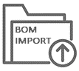

**STREAMLINE ERP IMPLEMENTATIONS WITH CADTALK BOM IMPORT UTILITY**

It can take weeks, even months, to create inventory items, bills of materials, and routings as you move from your old ERP system to your new ERP application. This process is fraught with manual data entry that is time-consuming and prone to human error.

This is the last thing you need when faced with the daunting task of switching ERP systems and you don’t want to start off with inaccurate bill of material, routing, or item errors that will cause significant issues with material planning, manufacturing costing, production scheduling, and virtually all manufacturing processes.

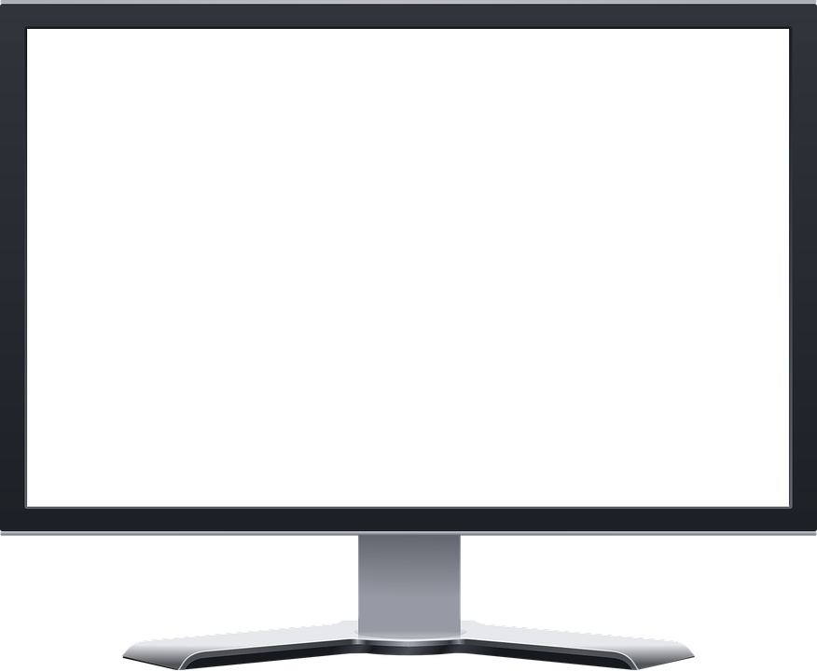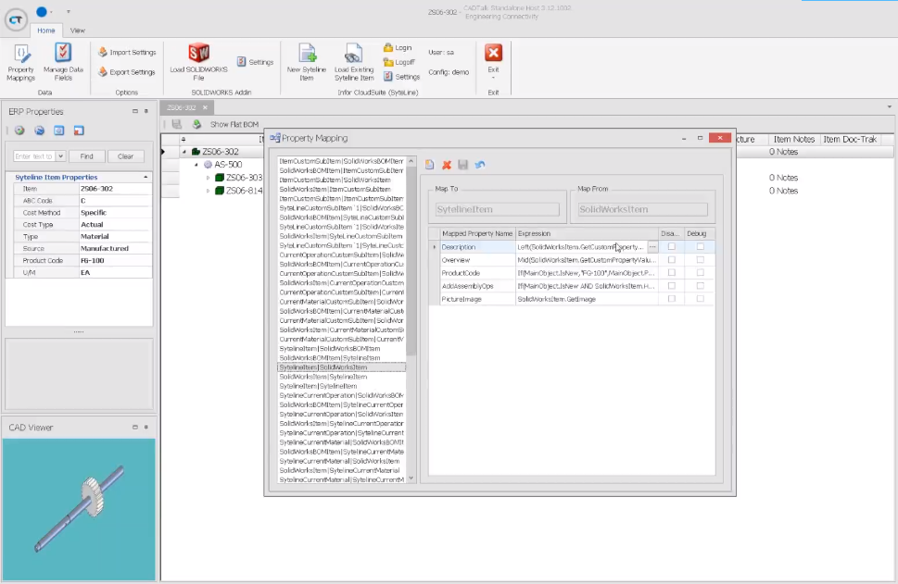

**The smart & efficient way to implement ERP**

CADTALK is an invaluable utility for manufacturers implementing new ERP systems. It transforms data from your library of CAD models, legacy ERP databases, or any data source including spreadsheets and flat files to create new items accurately in your ERP system. It can even create the inventory warehouse records for these items along with the manufacturing bill of materials and routings. The process can run unattended in the background as a service freeing you up to focus on other areas of your ERP implementation.

CADTALK’s BOM Import Utility leverages artificial intelligence and configurable rules to create and update thousands of records in your new ERP system in minutes compared to days or weeks of manual data entry which compounds and delays your ERP implementation.

And best of all, CADTALK ensures you have accurate and timely information in your ERP after you go live continuing to update item master files, bills of material, and routings for newly designed parts and revisions to existing parts.

Every company implementing a new ERP system can benefit from CADTALK BOM Import Utility to reduce implementation times potentially saving tens of thousands of dollars in implementation fees.

**Key Benefits**

* Reduce ERP implementation times
* Save thousands of dollars in ERP implementation costs
* Eliminate time-consuming manual data entry that is prone to error
* Ensure that items, inventory, bills of material, and routings are accurate
* Continue to utilize CADTALK after your ERP go-live to reduce the engineering to manufacturing hand-off by 80% (or more).

**FREE DEMO:** [**www.cadtalk.com/demo**](http://www.cadtalk.com/demo)