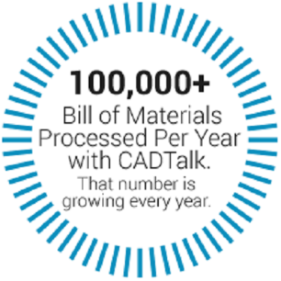

**Transform CAD BOMs to ERP with Rules-Based Artificial Intelligence**

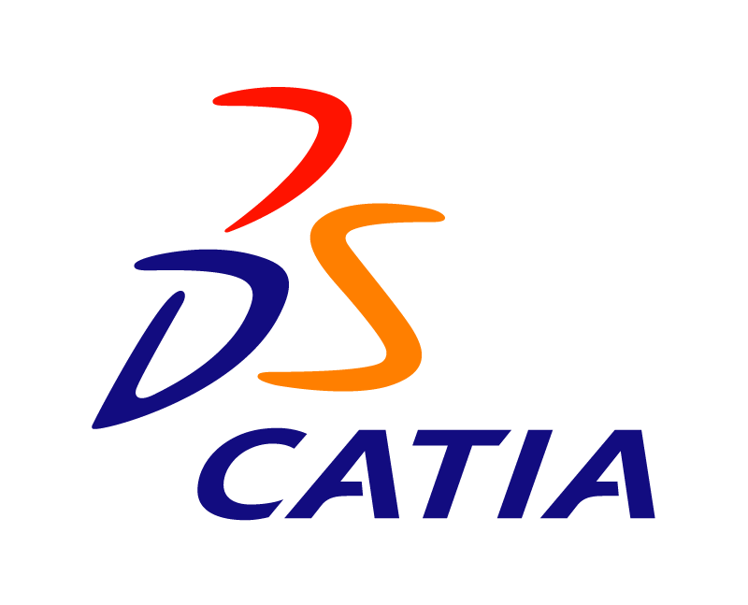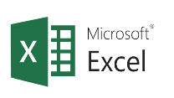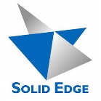

**CAD, PDM, PLM SYSTEMS**

**All These & Many More**

**AI-Powered CAD BOM to ERP Transformations**

CADTALK is the world’s first and only software leveraging artificial intelligence to transform engineering bills of material from virtually any CAD, PDM, or PLM application into manufacturing bills of material and routings inside most popular ERP applications.

Other applications on the market simply map data from CAD to ERP assuming the data is the same. Worse yet, they require engineers to duplicate ERP related data inside their CAD systems. This method is flawed and lacks sophisticated rules-based artificial intelligence to identify manufacturing operations, costs, and other ERP data that is required to take advantage of ERP features and like planning, scheduling, and costing.

CADTALK’s inherent intelligence allows it to calculate run times, identify vendors, and create inventory records or stock codes turning hours of mind-numbing work into minutes of effortless review saving you time and reducing data entry errors with precise production standards ensuring accurate material planning and production scheduling.

“CADTALK HAS BEEN AN IRREPLACEABLE TOOL IN HELPING US HANDLE A SIGNIFICANT INCREASE IN THE AMOUNT OF BILL OF MATERIALS DATA WE’VE BEEN REQUIRED TO PROCESS OVER THE LAST SEVERAL YEARS.”

Rob Ross P.E.

Engineering Services Manager

Cleaveland/Price Inc.

**Key Benefits**

* Faster engineering to production hand-off (80% faster on average)
* Reduce purchasing mistakes
* Automatic creation of new inventory records and stock codes
* Rules-based manufacturing routing creation
* Implement in about 8 hours
* Does not require additional CAD or ERP user licenses
* ROI typically in first 3 months

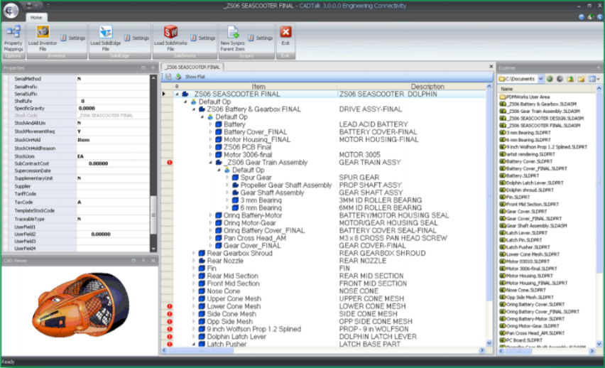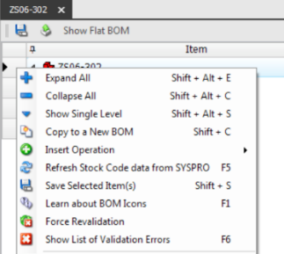

**FREE DEMO:** [**www.cadtalk.com/demo**](http://www.cadtalk.com/demo)