**Access ERP Data Inside CAD with Design for Manufacturing (DFM)**

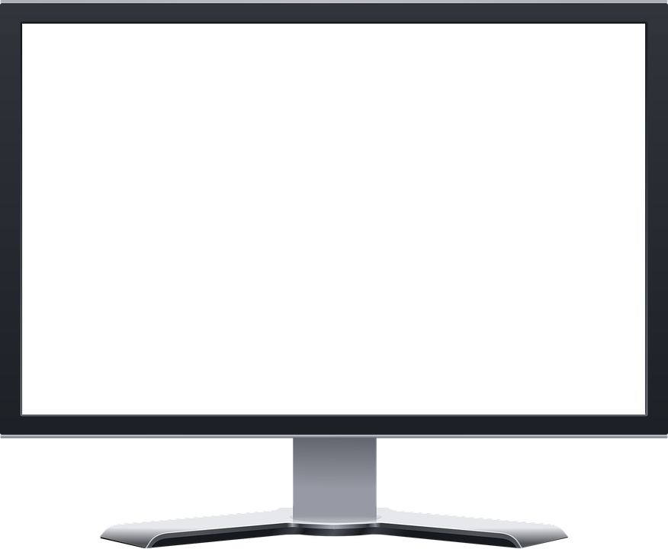

**Access ERP Part Data Inside CAD**

How can you design quality parts in CAD when half the information you need is isolated inside your ERP system? Do you find yourself continually logging in to the ERP application to get information or do you have to wait until someone with access to the ERP system gets you the information you need?

CADTALK Design for Manufacturing (DFM) provides access to every single piece of ERP data you need to design quality parts without leaving the comforts of your familiar CAD application.

View item attributes, vendors, warehouse locations, on-hand quantities, costing and accounting information, bills of material, work centers and machines, and much more.

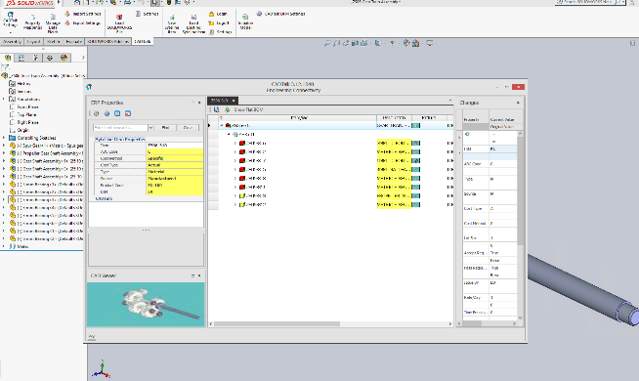

**Key Benefits**

* Access ERP Data inside CAD
* Eliminate dependence on costly ERP user licenses for engineers
* Avoid using obsolete or incorrect parts
* Issue valid part numbers for new items using ERP item formatting
* Automate creation or updates of items, bills of materials, and routings in ERP
* Set material properties by looking up raw materials in the ERP from CAD
* Set bend allowances for sheet metal parts based on manufacturing capabilities
* Reduce the engineering to manufacturing handoff by 80%

**Avoid Costly Design Mistakes with DFM**

Have you ever designed a new part and accidentally used an obsolete component in the bill of material? Or perhaps you chose the wrong component because the item id was similar to another item and you couldn’t differentiate one from the other without additional information stored in the ERP application.

It happens all the time. Engineers are isolated from the information they need to design parts that are easily transferred into the ERP system for manufacturing. CADTALK DFM not only provides the information you need, but it also automates the entire engineering to manufacturing handoff by leveraging artificial intelligence and configurable rules to create or update items, inventory records, bills of material, manufacturing routings, and other ERP data in minutes – all based on the CAD models you design.

Further, it can select vendors, pick the appropriate machines or work centers for cost rates, and calculate scrap and manufacturing run times ensuring that the parts are defined correctly for accurate costing, material planning, and production scheduling.

**FREE DEMO:** [**www.cadtalk.com/demo**](http://www.cadtalk.com/demo)